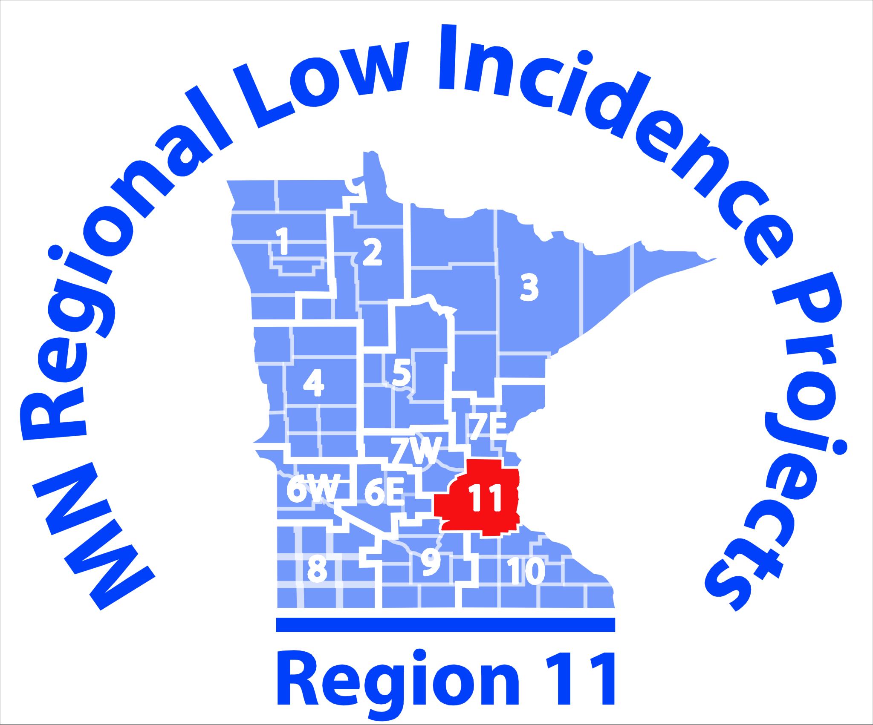
Agenda
8:30 – 9:00 AM
- Updates and News: Co-Coaches Taylor Thomas and Emily Manson
9:00 – 10:30 AM
- Danelle Gournaris -- Deaf Mentor Family Program : (http://www.lifetrack-mn.org/deaf-mentor-family-program)
- Chelsea Paulson -- Deaf/Hard of Hearing Role-Model Services (http://www.lifetrack-mn.org/rolemodel)
10:30 – 11:30 AM
- Discussion/Group Share of Resources; DMFP, DHH Role Model Services
11:30 AM – 12:00 PM
- Working Lunch, Updates from MDE and DHH CoP members
12:00 – 1:00
- Social Skills Presentation- Emily Manson
1:00 – 3:00
- Review and Discuss MN Social Skills Checklist for DHH - Emily Manson (http://education.state.mn.us/MDE/dse/sped/cat/dhh/)
- D/HH Toolkit- Develop/Share Social Skills Goals and Objectives
Note Taker: TBD
Upcoming Meetings in 2018: January 17, February 21, May 16

